大学英语四级口语考试试题构成

任务 | 任务名称 | 任务描述 | 时间
热身 | 自我介绍(Self introduction) | 考生作简短的自我介绍 | 每人20秒
1 | 短文朗读(Read aloud) | 考生经过准备后，朗读一篇短文 | 准备：45秒  答题：1分钟
2 | 简短回答(Question & answer) | 考生回答2个与所朗读的短文有关的问题 | 答题：每题20秒
3 | 个人陈述(Individual presentation) | 考生经过准备后，根据所给提示作1分钟发言 | 准备：45秒  答题：1分钟
4 | 小组互动(Pair work) | 两位考生经过准备后，根据设定的情景和任务进行交谈 | 准备：1分钟  答题：3分钟

大学英语四级口语考试样题
CET Spoken English Test – Band Four
Sample Paper

Topic A - 1
Topic Area: Daily Life
Topic: Travel
Examiner:
Hello, welcome to the CET Spoken English Test – Band Four. We wish you both good luck today. Now let’s begin with self-introductions.
Candidate A, would you please start? （考生A先回答，时间20秒）
Thank you. Candidate B, now it’s your turn. (然后考生B回答，时间20秒)
Thank you. OK, now that we know each other, let’s go on.
Examiner:
Task 1 Read Aloud
In this task, you are to read aloud a short passage. You will have 45 seconds to go over the passage and 1 minute to read it aloud. Now here is the passage.
(屏幕显示以下文字)
Many people would list San Francisco as one of the most delightful cities in the world. Sitting on the Pacific coast, it gives you a feeling of the sea. The sea breezes wake you up and make you eat well and sleep well. The city was planned with straight roads, and these roads cross each other at right angles, making squares as they do in many American cities. Very often you can find yourself on top of a hill in the city, looking down one of these straight roads as it rises and falls on its journey through the town. A good way to travel these roads is by cable car. These are buses that run on rails in the ground up and down the steep hills.
(考生准备时间45秒)
Now please begin to read on hearing the beep.
(考生A和B同时回答，时间1分钟)
Examiner:
Task 2 Question and Answer
In this task, you are to answer two questions. For each question, you will have 20 seconds to respond. Please start speaking on hearing the beep.
(问题文字不显示在屏幕上)
Question 1:
What would many people think of San Francisco according to the passage?
(考生A和B同时回答，时间20秒)
Question 2:
Which city in China do you like most? And why?
(考生A和B同时回答，时间20秒)
Examiner:
Task 3 Individual Presentation
In this task, you are to talk about the picture displayed on the screen. You will have 45 seconds to prepare and 1 minute to talk about it. Now here is the picture.
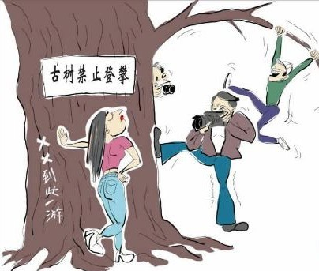
(考生准备时间45秒)
Now please start speaking on hearing the beep.
(考生A和B同时回答，时间1分钟)
Examiner:
Task 4 Pair Work
In this task, you are to talk with your partner about a plan of travel. Suppose you have three days to go sightseeing together. Talk with each other and make a plan for your trip. Your plan may include:
- place(s) to visit
- schedule
- means of transportation
You will have 1 minute to prepare and three minutes to talk. Remember, this is a pair activity and you need to interact with each other. Your performance will be judged according to your contribution to the pair work. Now please start to prepare.
(屏幕上显示以下文字)
Your plan may include:
- place(s) to visit
- schedule
- means of transportation
(考生准备时间1分钟)
Now please start your talk on hearing the beep.
(考生A和B讨论，时间3分钟)
Thank you. That is the end of the test.

